EXP – 1

clear;
clc;
close all;

% Design Parameters
Fs = 8000; % Sampling frequency in Hz
Ap = 1; % Passband ripple in dB

As = 40; % Stopband attenuation in dB

% 1. Low-Pass Filter Design
fp_lp = 1000; % LPF Passband frequency (Hz)
fs_lp = 1500; % LPF Stopband frequency (Hz)
wp_lp = fp_lp / (Fs/2);
ws_lp = fs_lp / (Fs/2);

[N_lp, Wn_lp] = buttord(wp_lp, ws_lp, Ap, As);
[b_lp, a_lp] = butter(N_lp, Wn_lp, &#39;low&#39;);

% 2. High-Pass Filter Design
fp_hp = 2500; % HPF Passband frequency (Hz)
fs_hp = 1800; % HPF Stopband frequency (Hz)
wp_hp = fp_hp / (Fs/2);
ws_hp = fs_hp / (Fs/2);

[N_hp, Wn_hp] = buttord(wp_hp, ws_hp, Ap, As);
[b_hp, a_hp] = butter(N_hp, Wn_hp, &#39;high&#39;);

% ==========================================
% DISPLAY NUMERICAL OUTPUTS IN COMMAND WINDOW
% ==========================================
fprintf(&#39;=== EXPERIMENT 1: BUTTERWORTH IIR FILTERS ===\n\n&#39;);

fprintf(&#39;--- LOW-PASS FILTER ---\n&#39;);
fprintf(&#39;Calculated Filter Order (N_lp): %d\n&#39;, N_lp);
fprintf(&#39;3-dB Cutoff Frequency (Wn_lp): %.4f Hz\n&#39;, Wn_lp * (Fs/2));
fprintf(&#39;Numerator Coefficients (b_lp):\n&#39;);

disp(b_lp);
fprintf(&#39;Denominator Coefficients (a_lp):\n&#39;);
disp(a_lp);

fprintf(&#39;--- HIGH-PASS FILTER ---\n&#39;);
fprintf(&#39;Calculated Filter Order (N_hp): %d\n&#39;, N_hp);
fprintf(&#39;3-dB Cutoff Frequency (Wn_hp): %.4f Hz\n&#39;, Wn_hp * (Fs/2));
fprintf(&#39;Numerator Coefficients (b_hp):\n&#39;);
disp(b_hp);
fprintf(&#39;Denominator Coefficients (a_hp):\n&#39;);
disp(a_hp);

% Frequency Response Calculation
[H_lp, f] = freqz(b_lp, a_lp, 1024, Fs);
[H_hp, ~] = freqz(b_hp, a_hp, 1024, Fs);

% Plotting
figure(&#39;Name&#39;, &#39;Butterworth IIR LPF and HPF&#39;);
subplot(2,2,1);
plot(f, 20*log10(abs(H_lp)), &#39;b&#39;, &#39;LineWidth&#39;, 1.5); grid on;
title([&#39;Butterworth LPF Magnitude (Order N = &#39;, num2str(N_lp), &#39;)&#39;]);
xlabel(&#39;Frequency (Hz)&#39;); ylabel(&#39;Magnitude (dB)&#39;); ylim([-80 5]);

subplot(2,2,2);
plot(f, angle(H_lp)*180/pi, &#39;r&#39;, &#39;LineWidth&#39;, 1.5); grid on;
title(&#39;Butterworth LPF Phase Response&#39;);
xlabel(&#39;Frequency (Hz)&#39;); ylabel(&#39;Phase (degrees)&#39;);

subplot(2,2,3);

plot(f, 20*log10(abs(H_hp)), &#39;b&#39;, &#39;LineWidth&#39;, 1.5); grid on;
title([&#39;Butterworth HPF Magnitude (Order N = &#39;, num2str(N_hp), &#39;)&#39;]);
xlabel(&#39;Frequency (Hz)&#39;); ylabel(&#39;Magnitude (dB)&#39;); ylim([-80 5]);

subplot(2,2,4);
plot(f, angle(H_hp)*180/pi, &#39;r&#39;, &#39;LineWidth&#39;, 1.5); grid on;
title(&#39;Butterworth HPF Phase Response&#39;);
xlabel(&#39;Frequency (Hz)&#39;); ylabel(&#39;Phase (degrees)&#39;);

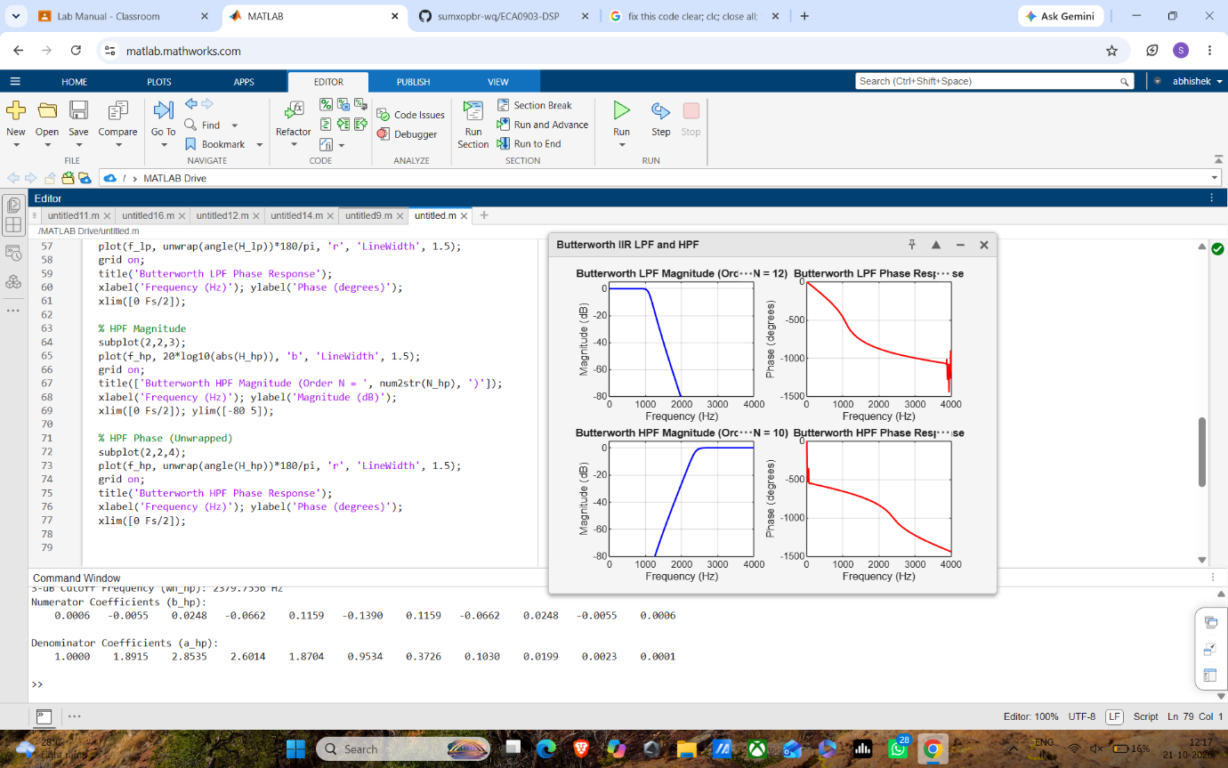

EXP -2
clear; clc; close all;

% Design Parameters
Fs = 8000; % Sampling frequency in Hz
Ap = 1; % Passband ripple in dB
As = 40; % Stopband attenuation in dB

% 1. Low-Pass Filter Design
fp_lp = 1000; % LPF Passband frequency (Hz)
fs_lp = 1500; % LPF Stopband frequency (Hz)
wp_lp = fp_lp / (Fs/2);
ws_lp = fs_lp / (Fs/2);
[N_lp, Wn_lp] = buttord(wp_lp, ws_lp, Ap, As);
[b_lp, a_lp] = butter(N_lp, Wn_lp, 'low');

% 2. High-Pass Filter Design
fp_hp = 2500; % HPF Passband frequency (Hz)
fs_hp = 1800; % HPF Stopband frequency (Hz)
wp_hp = fp_hp / (Fs/2);
ws_hp = fs_hp / (Fs/2);
[N_hp, Wn_hp] = buttord(wp_hp, ws_hp, Ap, As);
[b_hp, a_hp] = butter(N_hp, Wn_hp, 'high');

% ==========================================
% DISPLAY NUMERICAL OUTPUTS IN COMMAND WINDOW
% ==========================================
fprintf('=== EXPERIMENT 1: BUTTERWORTH IIR FILTERS ===\n\n');
fprintf('--- LOW-PASS FILTER ---\n');
fprintf('Calculated Filter Order (N_lp): %d\n', N_lp);
fprintf('3-dB Cutoff Frequency (Wn_lp): %.4f Hz\n', Wn_lp * (Fs/2));
fprintf('Numerator Coefficients (b_lp):\n'); disp(b_lp);
fprintf('Denominator Coefficients (a_lp):\n'); disp(a_lp);

fprintf('--- HIGH-PASS FILTER ---\n');
fprintf('Calculated Filter Order (N_hp): %d\n', N_hp);
fprintf('3-dB Cutoff Frequency (Wn_hp): %.4f Hz\n', Wn_hp * (Fs/2));
fprintf('Numerator Coefficients (b_hp):\n'); disp(b_hp);
fprintf('Denominator Coefficients (a_hp):\n'); disp(a_hp);

% Frequency Response Calculation
[H_lp, f_lp] = freqz(b_lp, a_lp, 1024, Fs);
[H_hp, f_hp] = freqz(b_hp, a_hp, 1024, Fs);

% Plotting
figure('Name', 'Butterworth IIR LPF and HPF', 'NumberTitle', 'off');

% LPF Magnitude
subplot(2,2,1);
plot(f_lp, 20*log10(abs(H_lp)), 'b', 'LineWidth', 1.5);
grid on;
title(['Butterworth LPF Magnitude (Order N = ', num2str(N_lp), ')']);
xlabel('Frequency (Hz)'); ylabel('Magnitude (dB)');
xlim([0 Fs/2]); ylim([-80 5]);

% LPF Phase (Unwrapped)
subplot(2,2,2);
plot(f_lp, unwrap(angle(H_lp))*180/pi, 'r', 'LineWidth', 1.5);
grid on;
title('Butterworth LPF Phase Response');
xlabel('Frequency (Hz)'); ylabel('Phase (degrees)');
xlim([0 Fs/2]);

% HPF Magnitude
subplot(2,2,3);
plot(f_hp, 20*log10(abs(H_hp)), 'b', 'LineWidth', 1.5);
grid on;
title(['Butterworth HPF Magnitude (Order N = ', num2str(N_hp), ')']);
xlabel('Frequency (Hz)'); ylabel('Magnitude (dB)');
xlim([0 Fs/2]); ylim([-80 5]);

% HPF Phase (Unwrapped)
subplot(2,2,4);
plot(f_hp, unwrap(angle(H_hp))*180/pi, 'r', 'LineWidth', 1.5);
grid on;
title('Butterworth HPF Phase Response');
xlabel('Frequency (Hz)'); ylabel('Phase (degrees)');
xlim([0 Fs/2]);

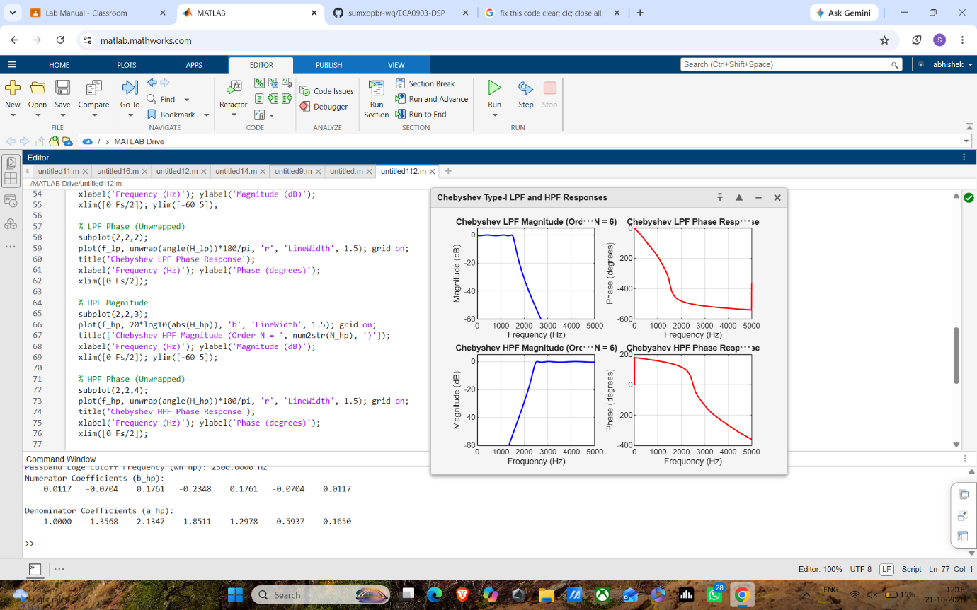

EXP – 3
clear; clc; close all;

% Design Parameters
Fs = 10000; % Sampling frequency in Hz
Ap = 0.5; % Passband ripple in dB
As = 30; % Stopband attenuation in dB

% 1. Low-Pass Filter Design
fp_lp = 1500; % Passband frequency (Hz)
fs_lp = 2000; % Stopband frequency (Hz)
wp_lp = fp_lp / (Fs/2);
ws_lp = fs_lp / (Fs/2);

[N_lp, Wn_lp] = cheb1ord(wp_lp, ws_lp, Ap, As);
[b_lp, a_lp] = cheby1(N_lp, Ap, Wn_lp, 'low');

% 2. High-Pass Filter Design
fp_hp = 2500; % Passband frequency (Hz)
fs_hp = 1800; % Stopband frequency (Hz)
wp_hp = fp_hp / (Fs/2);
ws_hp = fs_hp / (Fs/2);

[N_hp, Wn_hp] = cheb1ord(wp_hp, ws_hp, Ap, As);
[b_hp, a_hp] = cheby1(N_hp, Ap, Wn_hp, 'high');

% ==========================================
% DISPLAY NUMERICAL OUTPUTS IN COMMAND WINDOW
% ==========================================
fprintf('=== EXPERIMENT 2: CHEBYSHEV TYPE-I IIR FILTERS ===\n\n');

fprintf('--- CHEBYSHEV LOW-PASS FILTER ---\n');
fprintf('Calculated Filter Order (N_lp): %d\n', N_lp);
fprintf('Passband Edge Cutoff Frequency (Wn_lp): %.4f Hz\n', Wn_lp * (Fs/2));
fprintf('Numerator Coefficients (b_lp):\n'); disp(b_lp);
fprintf('Denominator Coefficients (a_lp):\n'); disp(a_lp);

fprintf('--- CHEBYSHEV HIGH-PASS FILTER ---\n');
fprintf('Calculated Filter Order (N_hp): %d\n', N_hp);
fprintf('Passband Edge Cutoff Frequency (Wn_hp): %.4f Hz\n', Wn_hp * (Fs/2));
fprintf('Numerator Coefficients (b_hp):\n'); disp(b_hp);
fprintf('Denominator Coefficients (a_hp):\n'); disp(a_hp);

% Frequency Response Calculation
[H_lp, f_lp] = freqz(b_lp, a_lp, 1024, Fs);
[H_hp, f_hp] = freqz(b_hp, a_hp, 1024, Fs);

% Plotting
figure('Name', 'Chebyshev Type-I LPF and HPF Responses', 'NumberTitle', 'off');

% LPF Magnitude
subplot(2,2,1);
plot(f_lp, 20*log10(abs(H_lp)), 'b', 'LineWidth', 1.5); grid on;
title(['Chebyshev LPF Magnitude (Order N = ', num2str(N_lp), ')']);
xlabel('Frequency (Hz)'); ylabel('Magnitude (dB)');
xlim([0 Fs/2]); ylim([-60 5]);

% LPF Phase (Unwrapped)
subplot(2,2,2);
plot(f_lp, unwrap(angle(H_lp))*180/pi, 'r', 'LineWidth', 1.5); grid on;
title('Chebyshev LPF Phase Response');
xlabel('Frequency (Hz)'); ylabel('Phase (degrees)');
xlim([0 Fs/2]);

% HPF Magnitude
subplot(2,2,3);
plot(f_hp, 20*log10(abs(H_hp)), 'b', 'LineWidth', 1.5); grid on;
title(['Chebyshev HPF Magnitude (Order N = ', num2str(N_hp), ')']);
xlabel('Frequency (Hz)'); ylabel('Magnitude (dB)');
xlim([0 Fs/2]); ylim([-60 5]);

% HPF Phase (Unwrapped)
subplot(2,2,4);
plot(f_hp, unwrap(angle(H_hp))*180/pi, 'r', 'LineWidth', 1.5); grid on;
title('Chebyshev HPF Phase Response');
xlabel('Frequency (Hz)'); ylabel('Phase (degrees)');
xlim([0 Fs/2]);

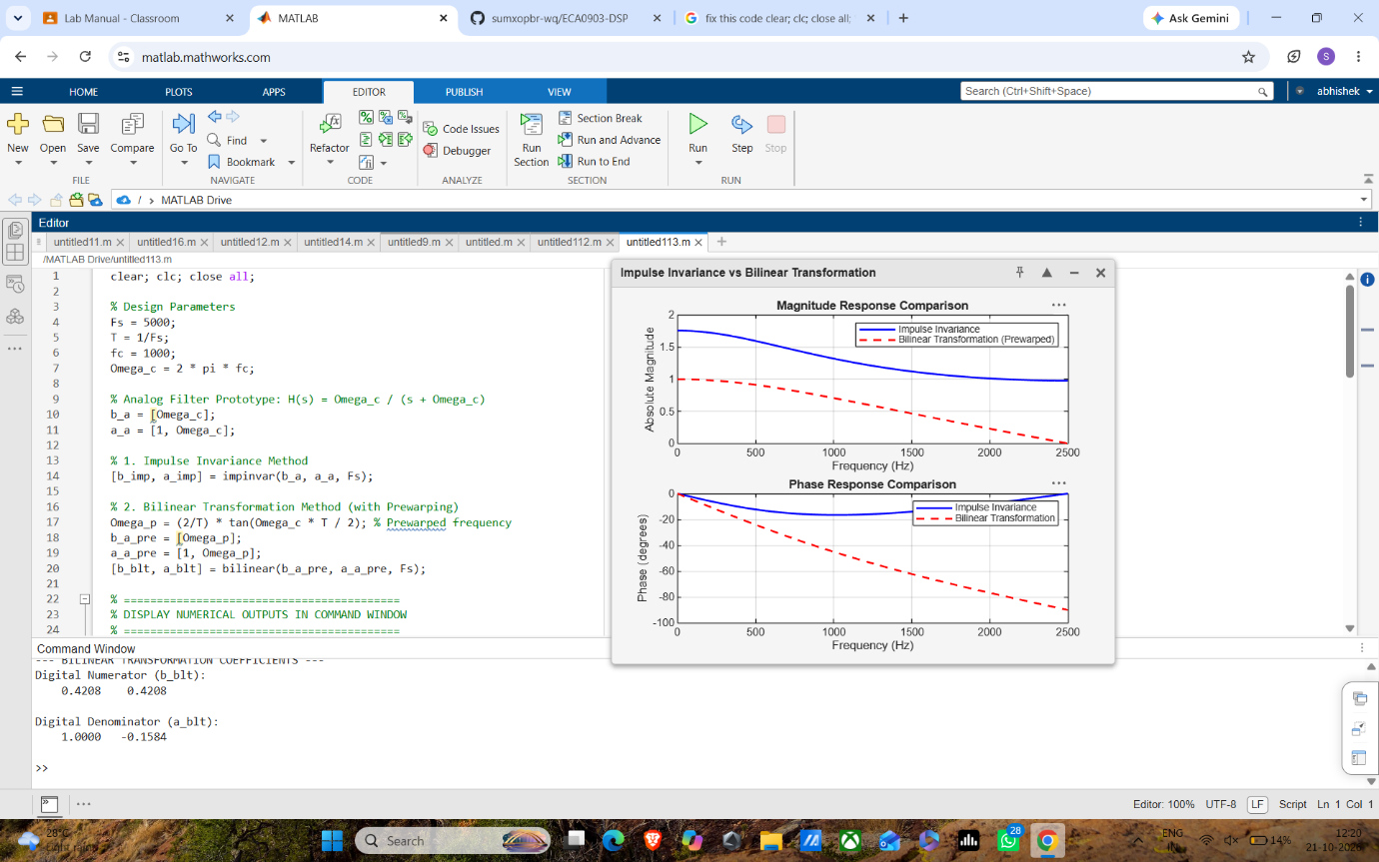

EXP -4
clear; clc; close all;

% Design Parameters
Fs = 5000;
T = 1/Fs;
fc = 1000;
Omega_c = 2 * pi * fc;

% Analog Filter Prototype: H(s) = Omega_c / (s + Omega_c)
b_a = [Omega_c];
a_a = [1, Omega_c];

% 1. Impulse Invariance Method
[b_imp, a_imp] = impinvar(b_a, a_a, Fs);

% 2. Bilinear Transformation Method (with Prewarping)
Omega_p = (2/T) * tan(Omega_c * T / 2); % Prewarped frequency
b_a_pre = [Omega_p];
a_a_pre = [1, Omega_p];
[b_blt, a_blt] = bilinear(b_a_pre, a_a_pre, Fs);

% ==========================================
% DISPLAY NUMERICAL OUTPUTS IN COMMAND WINDOW
% ==========================================
% Fixed the broken multi-line string literal syntax error here:
fprintf('=== EXPERIMENT 3: IMPULSE INVARIANCE vs BILINEAR TRANSFORMATION ===\n\n');

fprintf('Analog Cutoff Frequency (Omega_c): %.2f rad/s\n', Omega_c);
fprintf('Prewarped Analog Frequency (Omega_p): %.2f rad/s\n\n', Omega_p);

fprintf('--- IMPULSE INVARIANCE COEFFICIENTS ---\n');
fprintf('Digital Numerator (b_imp):\n'); disp(b_imp);
fprintf('Digital Denominator (a_imp):\n'); disp(a_imp);

fprintf('--- BILINEAR TRANSFORMATION COEFFICIENTS ---\n');
fprintf('Digital Numerator (b_blt):\n'); disp(b_blt);
fprintf('Digital Denominator (a_blt):\n'); disp(a_blt);

% Frequency Responses
[H_imp, f_imp] = freqz(b_imp, a_imp, 1024, Fs);
[H_blt, f_blt] = freqz(b_blt, a_blt, 1024, Fs);

% Plotting
figure('Name', 'Impulse Invariance vs Bilinear Transformation', 'NumberTitle', 'off');

% Magnitude Response Comparison
subplot(2,1,1);
plot(f_imp, abs(H_imp), 'b', 'LineWidth', 1.5); hold on;
plot(f_blt, abs(H_blt), 'r--', 'LineWidth', 1.5); grid on;
legend('Impulse Invariance', 'Bilinear Transformation (Prewarped)');
title('Magnitude Response Comparison');
xlabel('Frequency (Hz)'); ylabel('Absolute Magnitude');
xlim([0 Fs/2]);

% Phase Response Comparison (Unwrapped)
subplot(2,1,2);
plot(f_imp, unwrap(angle(H_imp))*180/pi, 'b', 'LineWidth', 1.5); hold on;
plot(f_blt, unwrap(angle(H_blt))*180/pi, 'r--', 'LineWidth', 1.5); grid on;
legend('Impulse Invariance', 'Bilinear Transformation');
title('Phase Response Comparison');
xlabel('Frequency (Hz)'); ylabel('Phase (degrees)');
xlim([0 Fs/2]);

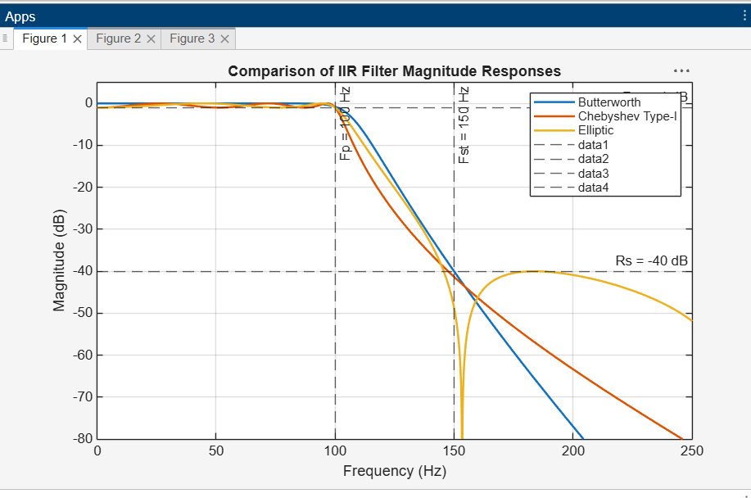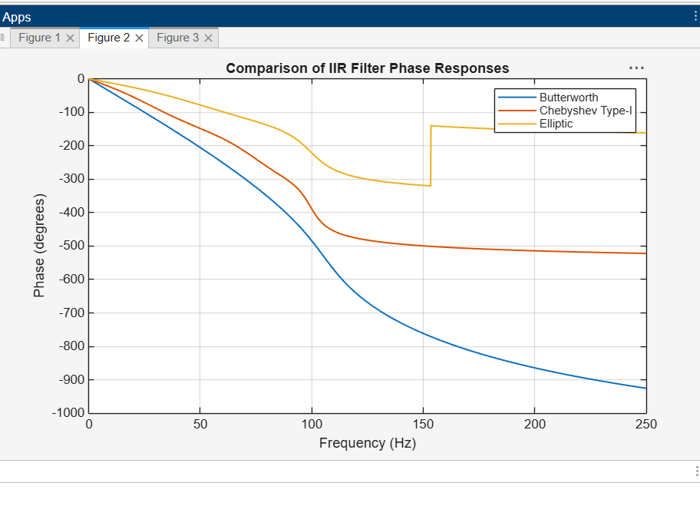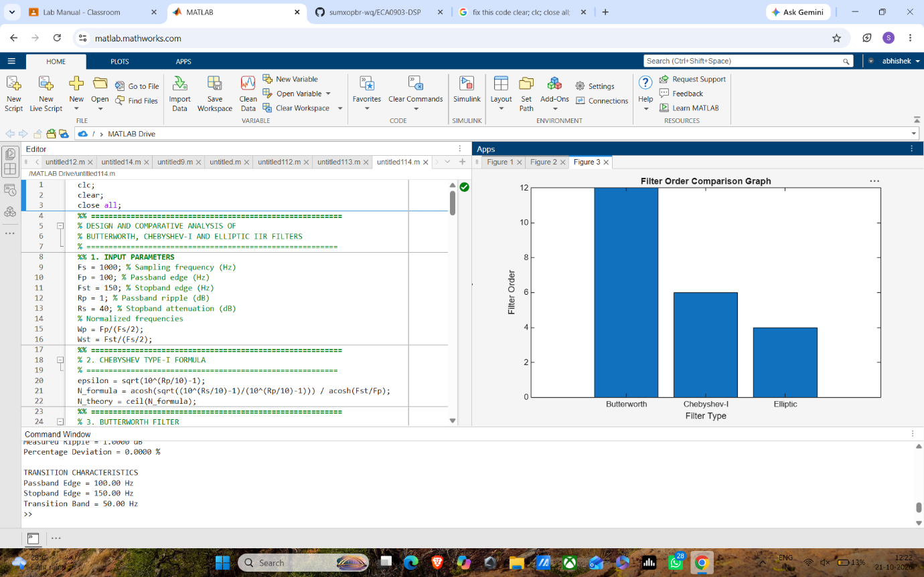

EXP -5
clc; clear; close all;

%% IIR Filter Coefficients
b = [0.0048 0.0193 0.0289 0.0193 0.0048];
a = [1 -2.3695 2.3140 -1.0547 0.1874];

N = 50;
x = [1 zeros(1,N-1)]; % Unit impulse
n = 0:N-1;

%% 1. Direct Form-I and Direct Form-II
y1 = filter(b,a,x); % Direct Form-I
y2 = filter(b,a,x); % Direct Form-II

%% 2. Cascade Realization
[sos,g] = tf2sos(b,a);
yc = g*x;

for k = 1:size(sos,1)
yc = filter(sos(k,1:3),sos(k,4:6),yc);
end

%% 3. Parallel Realization
[r,p,k] = residuez(b,a);
yp = filter(k,1,x);

for i = 1:length(r)
yp = yp + filter(r(i),[1 -p(i)],x);
end

%% 4. Display Coefficients
disp('=======================================')
disp('IIR FILTER REALIZATION')
disp('=======================================')
disp('Numerator coefficients b ='); disp(b)
disp('Denominator coefficients a ='); disp(a)

disp('Second Order Sections (Cascade) ='); disp(sos)
disp('Cascade Gain ='); disp(g)

disp('Residues (Parallel) ='); disp(r)
disp('Poles (Parallel) ='); disp(p)
disp('Direct term ='); disp(k)

%% 5. Error and Percentage Deviation
% Compute matching 4x1 column vectors for all structures
E = [
0; % DF-I vs DF-I (Reference)
max(abs(y1 - y2)); % DF-I vs DF-II
max(abs(y1 - yc)); % DF-I vs Cascade
max(abs(y1 - yp)) % DF-I vs Parallel
];

D = (E / max(abs(y1))) * 100;

% Construct the table with properly dimensioned column vectors
T = table(["DF-I"; "DF-II"; "Cascade"; "Parallel"], ...
E, ...
D, ...
'VariableNames', {'Structure', 'Maximum_Error', 'Deviation_percent'});

disp('Comparison Table:')
disp(T)

%% 6. Impulse Response Comparison
figure('Name', 'Impulse Response Comparison', 'NumberTitle', 'off');
% Wrapped outputs in real() to remove complex numerical precision noise
stem(n, real(y1), 'filled'); hold on;
stem(n, real(y2), '--');
stem(n, real(yc), ':', 'LineWidth', 1.5);
stem(n, real(yp), '-.');
grid on;
xlabel('n');
ylabel('Amplitude');
title('Impulse Response of IIR Realizations');
legend('Direct Form-I', 'Direct Form-II', 'Cascade', 'Parallel');
xlim([0 N-1]);

%% 7. Error Plot
figure('Name', 'Numerical Error Analysis', 'NumberTitle', 'off');
plot(n, abs(y1-y2), '--', 'LineWidth', 1.2); hold on;
plot(n, abs(y1-yc), ':', 'LineWidth', 1.5);
plot(n, abs(y1-yp), '-.', 'LineWidth', 1.2);
grid on;
xlabel('n');
ylabel('Absolute Error');
title('Numerical Precision Deviation from DF-I Reference');
legend('DF-I vs DF-II', 'DF-I vs Cascade', 'DF-I vs Parallel');
xlim([0 N-1]);

%% 8. Frequency Response
figure('Name', 'Frequency Response', 'NumberTitle', 'off');
freqz(b,a,1024);
title('Frequency Response of IIR Filter');

%% 9. Pole-Zero Plot
figure('Name', 'Pole-Zero Analysis', 'NumberTitle', 'off');
zplane(b,a);
title('Pole-Zero Plot');

